Supporting Information for
Supporting Information for

Mechanically-Robust Electrospun Nanocomposite Fiber Membranes for Oil and Water Separation

Marat Nueraji,ª Zhexenbek Toktarbay,^{b} Aida Ardakkyzy,^{c} Deepak Sridhar,^{d,e} Hassan Algadi,^{f} Ben Bin Xu,^{g} Jalal T. Althakafy,^{h} Abdullah K. Alanazi,^{i} Hala M. Abo-Dief,^{j} Salimgerey Adilov,^{c,*} and Zhanhu Guo^{d,g*}

ª Edward R. Murrow High School, Brooklyn, NY 11230, USA.
^{b} Renewable Energy Systems and Material Science Laboratory, National Laboratory Astana (NLA), Nazarbayev University, Kabanbay Batyr 53, Astana,010000, Kazakhstan.
^{c}Department of Chemistry, School of Science and Humanities, Nazarbayev University, Kabanbay Batyr 53, Astana,010000, Kazakhstan.
^{d} Integrated Composites Lab (ICL), Department of Chemical and Biological Engineering, University of Tennessee, Knoxville, TN, USA
^{e} Zentek Ltd. 24 Corporate Crt, Guelph, Ontario, N1G 5G5 Canada
^{f} Department of Electrical Engineering, Faculty of Engineering, Najran University, Najran, 11001, Saudi Arabia
^{g} Mechanical and Construction Engineering, Faculty of Engineering and Environment, Northumbria University, Newcastle Upon Tyne, NE1 8ST, UK
h Department of Chemistry, Faculty of Applied Science, Umm Al-Qura University, Makkah 24230, Saudi Arabia
i Department of Chemistry, College of Science, Taif University, P.O. Box 11099, Taif 21944, Saudi Arabia
^{j} Department of Science and Technology, University College-Ranyah, Taif University, P.O. Box 11099, Taif 21944, Saudi Arabia

*: sadilov@nu.edu.kz (S. Adilov); or zhanhu.guo@northumbria.ac,uk (Z. Guo)

Methods
Sample Preparation
The polystyrene fibers with 0.025% concentration of carbon nanotube were labeled as C. While with graphene concentrations of 0.025% and 0.075% were labeled as C10 and C30 respectively. Polystyrene fibers were labeled as PS. The samples were adhered to a glass substrate through a thermoplastic adhesive. In the first step, the adhesive in melted form was spread on glass and then fibers were introduced to it. The inferior portion of fibers was entrapped into the adhesive and got fixed permanently after 3 minutes of cooling at room temperature. The superior portion of fibers was bare for AFM tip interactions.
Atomic force microscopy
Atomic force microscope (NanoWizard III, JPK Instruments) was used to measure the height and Young’s modulus of fibers. This AFM offers a 100 μm x 100 μm lateral and 15um vertical range of scanning with various imaging modes.
Calibration of probe
We used a spherical B150-Cont cantilever (NanoAndMore) with a listed spring constant of 0.2N/m and a diameter of 150nm for all composite materials. Additionally, Needle cantilever (Nauganeedles LLC) with a listed spring constant of 0.2N/m and a radius of 25 nm was used specifically for PS. It was required because B150 was producing much noise in PS imaging.
The sensitivity and spring constant of the B150 probe was calibrated by the built-in contact-free method based on thermal noise calibration [1]. while the sensitivity of nauga needle was calibrated by the contact-based method through AC mode. To get spring constant for nauga needle, thermal noise method was used. The estimated spring constant for B150 was 0.383 N/m, and for nauga needle it was 0.266 ± 0.03 N/m.
Imaging
Quantitative imaging mode™ of JPK data acquisition application was used to produce topography and other properties of fibers. The selected area for imaging of each fiber was 30μm², and the setpoint was 15nN.

Data Processing
Indentation forces were stored with default extension of *.jpk-qi-data, and for images, the file was stored with extension of *.jpk-qi-image. All measurements were processed with manufacturers supplied ‘JPK data processing’ application.
After opening the data file, it was processed with a hertz model (see Equation 1). Usage of a soft cantilever and Hertzian model for samples having modulus less than 1 GPa is effective even with strong adhesive forces[2]. Additionally, the fibrous material was not susceptible to plastic deformation, and individual fibers had a diameter in the micrometer range compared to cantilever tips which were in nanometer. The E (Elastic Modulus) = F (Loading Force), we can calculate it by the given formula:
$F=\frac{4}{3} E^{*} \sqrt{Rd^{3}}$ (1)
where F= Loading Force, E*= Effective Elastic Modulus, R= Radius of Tip, d= Displacement of elastic half distance by R. Furthermore E* depends upon the elastic modulus and passion ratio of tip and sample. As poison ratio and Young’s modulus of indenter were very heigh as compared to sample so these parameters set to negligible in Equation (2)(Ning et al., 2018).
$E^{*}=\frac{1-V_{tip}^{2}}{E_{tip}}+\frac{1-V_{sample}^{2}}{E_{Sample}}$ (2)
The tip sample interaction is illustrated in the Figure S-1. When force acts on the surface of sample it produces indentation and this indentations is measured as displacement.
Before converging, some corrections were applied to the force curves. At the start, values of the tip’s sensitivity and spring constant data were inserted in the calibration tab. The area of the curve before the tip-sample interaction was not leveled. Therefore, baseline was fitted by subtracting offset + tilt. Furthermore, offset fit also helps to eliminate environmental effects between tip and sample interactions.
After applying contact point adjustment parameter and vertical tip position, to calculate zero force line and to correct tip height signal respectively, the elasticity fit is applied. The geometry of the tip and its required values were inserted in the elasticity fit tab.
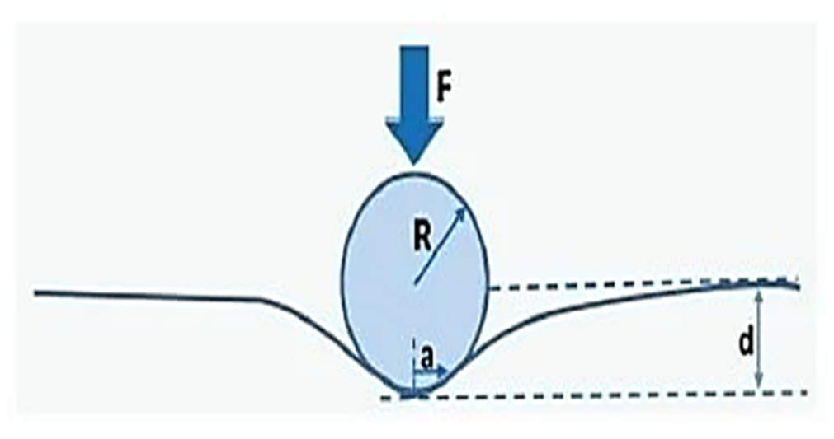
Figure S1. Illustration of spherical tip and sample interaction showing the displacement created in the sample surface as force is applied.

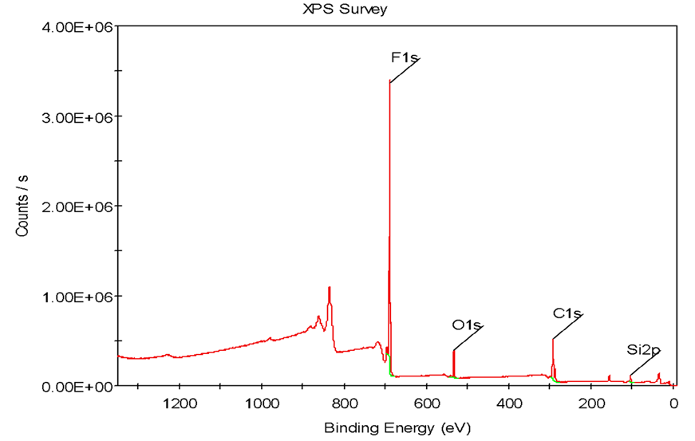
Figure S2. XPS analysis for modified MWCNT

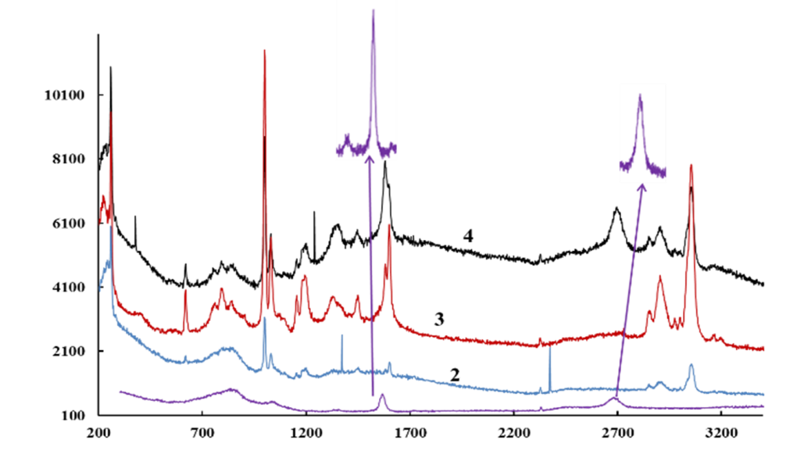
Figure S3. Raman spectroscopy analysis MWCNT (1), PS fiber (2), PS-MWCNT-SiF (3) and PS-G-SiF (4) fibre.

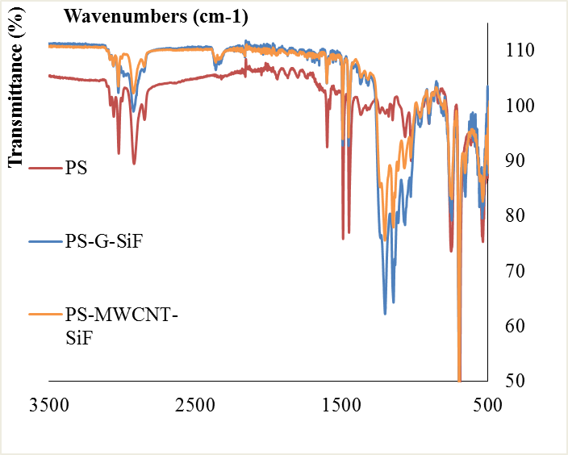

Figure S4. FTIR analysis of Polystyrene (PS), PS-MWCNT-SiF and PS-G-SiF fibers.

Figure S5 video for oil water separation

